Teacher Preparation Notes for “Enzymes Help Us Digest Food”

In this hands-on, minds-on activity, students investigate the biological causes of Maria’s symptoms and Jayden’s symptoms. To explore the causes of these symptoms, students carry out two experiments, interpret the results, and answer additional analysis and discussion questions. Students learn about enzyme function and enzyme specificity as they figure out that Maria’s symptoms are due to lactase deficiency (which can result in lactose intolerance) and Jayden’s symptoms are due to sucrase deficiency. In the final section, students are challenged to generalize their understanding of enzymes to interpret a video of an experiment with saliva, starch and iodine. This activity can be used in an introductory unit on biological molecules or later during a discussion of enzymes.

Before beginning this activity, students should have a basic understanding of molecules and chemical reactions. This activity will probably take approximately two 50-minute laboratory periods. You may want to introduce the activity with page 1 of the Student Handout + question 3 on the day before the first laboratory period. If you want to simplify this activity, you can omit question 3b, test tubes 3 and 4 from the Procedure and Results, and question 6.

Table of Contents
Learning Goals – pages 1-2
Equipment and Supplies – pages 2-3
Instructional Suggestions and Background Information
General – page 3
Maria’s problem – pages 3-4
What does the enzyme lactase do? – pages 4-6
How Too Little Lactase Can Cause Symptoms When a Person Drinks Milk – pages 6-8
Jayden’s problem is different from Maria’s problem. – pages 8-10
Interpreting an Experiment with Starch and Saliva – pages 10-11
Additional Resources – page 11

Learning Goals
Specific Content Learning Goals
- An enzyme is a molecule (usually a protein) that speeds up a chemical reaction. Without the enzyme, the reaction typically occurs extremely slowly or not at all.
- An enzyme acts on substrate(s) to produce product(s). The substrate binds to the active site of the enzyme.
- Some enzymes break down (digest) larger molecules that come from our food to smaller molecules that can be absorbed into our blood. For example, lactase breaks down lactose into glucose and galactose.
- An enzyme molecule returns to its original state after acting on the substrate, so each enzyme molecule can be reused over and over again. For example, a single molecule of lactase can break down many, many molecules of lactose.
- Each enzyme acts only on a specific substrate (or several chemically similar substrates) because only that specific substrate fits the enzyme’s active site. For example, lactase digests lactose, but not sucrose. Because of enzyme specificity, many different enzymes are needed to digest all the different molecules in food.
- This learning activity illustrates that proteins are not just abstract concepts in biology textbooks, but real parts of our bodies that have observable effects on our characteristics and health. For example, a person who makes very little lactase in his/her small intestines can only digest small amounts of lactose at a time. Consumption of larger amounts of lactose in a short time period can result in the symptoms of lactose intolerance.

In accord with the Next Generation Science Standards
- This activity helps students to prepare for the Performance Expectation, HS-LS1-1, "Construct an explanation based on evidence for how… proteins… carry out the essential functions of life…."
- Students learn the Disciplinary Core Idea (LS1.A), "… proteins… carry out most of the work of cells."
- Students engage in recommended Scientific Practices, including "Constructing Explanations: Apply scientific ideas, principles, and/or evidence to provide an explanation of phenomena….”
- This activity provides the opportunity to discuss the Crosscutting Concept: "Cause and Effect: Mechanism and Prediction: Cause and effect relationships can be suggested and predicted for complex natural and human designed systems by examining what is known about smaller scale mechanisms within the system."

Equipment and Supplies
For each group of four students:
- 30 mL lactose solution (5 g lactose per 100 mL water; lactose is readily available from a variety of suppliers on the web)
- 20 mL milk
- 20 mL sucrose solution (5 g sucrose per 100 mL water)
- 6 mL lactase solution (1 g lactase per 50 mL water; you can order lactase from Fisher (https://www.fishersci.com/shop/products/mp-biomedicals-lactase-aspergillus-oryzae/p-4605366). Store the lactase in the refrigerator. Make the solution on the day your students will use it. When you make the solution, you will need to smoosh the lumps and stir a lot.)
- 4 mL invertase solution (called sucrase in the Student Handout) (4 g of invertase per 50 mL water; you can order invertase from Carolina (https://www.carolina.com/specialty-chemicals-d-l/invertase-powder-reagent-grade-100-g/868900.pr). Make the solution on the day your students will use it. Store the invertase solution in the refrigerator.
- 8 1-mL transfer pipettes
- 8 gloves (only needed if your test tubes do not have caps)
- 8 visually readable glucose test strips (a.k.a. urinalysis glucose test strips; these glucose test strips are available from http://www.carolina.com/catalog/detail.jsp?prodId=695960&s_cid=ppc_gl_products&gclid=CIWU8MHxr8YCFY09gQodSjUITA or search on the web for urinalysis glucose test strips. For the Carolina test strips, students should evaluate the change in color at 3 minutes after dipping the test strip in the solution. For other brands of test strips, you will want to pilot test the best interval to wait before reading the specific glucose test strips you have purchased. You may need to change the second sentence in step E of the Procedure on pages 3 and 7 of the Student Handout.)

For each student group in your largest class:
- 4 beakers to hold the solutions for each experiment
- 4 15-mL test tubes
- color chart for interpreting the test strips
- test tube rack (or something else to keep the test tubes upright)
- fine-tipped permanent marker for labeling the beakers, pipettes and test tubes

Instructional Suggestions and Background Information
You can maximize student participation and learning by having your students work in pairs or small groups to complete groups of related questions, and then having a class discussion of each group of related questions. In each discussion, you can probe student thinking and help your students to develop a sound understanding of the concepts and information covered, before moving on to the next group of related questions.

In the Student Handout, numbers in bold indicate questions for the students to answer and letters in bold indicate steps in the experimental procedures for the students to do.

You can use the Word document to make revisions. If you use the Word version of the Student Handout, please check the PDF of the Student Handout, which shows the correct format.

A key is available upon request to Ingrid Waldron (iwaldron@upenn.edu). The following pages provide instructional suggestions and additional background information – some for inclusion in your class discussions and some to provide you with relevant background that may be useful for your understanding and/or for responding to student questions.

Maria’s problem
Early on, you will want to emphasize the difference between the sugar lactose and the enzyme lactase.

Question 1 presents the driving question for pages 1-5 of the Student Handout. Question 1 should be used to elicit students’ initial ideas and not to arrive at definitive conclusions. Unresolved questions should be revisited as you work your way through pages 1-5. If your students are not entirely comfortable with molecular diagrams, you may want to ask them to identify all the carbon atoms in one of the sugars.

Glucose, galactose and fructose all have the chemical formula C₆H₁₂O₆, but the atoms are arranged differently so these three sugars are isomers. (See figure below.) Galactose is a stereoisomer of glucose since the identical chemical groups are bonded to the same carbon atoms, but with one difference in orientation. Fructose is a structural isomer of glucose since it contains the same atoms organized in a different molecular structure.
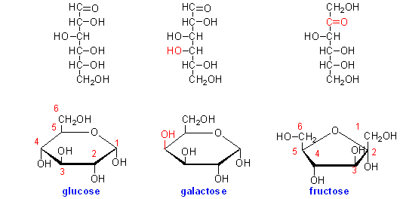
(http://david-bender.co.uk/metabonline/CHO/GI/images/monosacchs.png)

What does the enzyme lactase do?
In this section, students will design and carry out an experiment to test their hypothesis about what the enzyme lactase does (presented in student answers to questions 1b and 2). In addition, students design and carry out an experiment to test the hypothesis that milk contains lactose. We recommend that you demonstrate the use of a glucose test strip before question 3. If you want to simplify this activity, you can omit question 3b, test tubes 3 and 4 from the Procedure and Results, and question 6.

The experiment that students carry out in this section will show that, without the enzyme lactase, the digestion of lactose is so slow that no detectable glucose is produced in three minutes. You may want to mention that we say that an enzyme is required for a chemical reaction when the rate of reaction without the enzyme is too slow to be biologically useful.

Glucose test strips can be used to test for glucose in a person’s urine. If glucose is present in the urine, this indicates that blood glucose levels are too high. A person with chronically high blood glucose levels has diabetes (https://www.merckmanuals.com/home/hormonal-and-metabolic-disorders/diabetes-mellitus-dm-and-disorders-of-blood-sugar-metabolism/diabetes-mellitus-dm).

Glucose test strips only react with the monosaccharide glucose and do not react with glucose when the glucose is part of the disaccharides, lactose or sucrose. If a student group gets an unexpected positive test, this probably indicates contamination or waiting too long to read the glucose test strip.

You may find the figure below useful if you want to explain to your students that enzymes speed up biological processes by reducing the activation energy that is required to get to the transition state in chemical reactions. An enzyme can lower the required activation energy by stressing particular chemical bonds of a substrate or bringing two substrate molecules together in the correct orientation to react with each other. Without an enzyme, the activation energy typically is so high that very few substrate molecules will have sufficient thermal energy to undergo the reaction. In contrast, with an enzyme, many more substrate molecules will have sufficient thermal energy to meet the lower activation energy requirement, so the reaction will proceed at a biologically useful rate. The 4.5-minute video, “How Enzymes Work” (https://www.youtube.com/watch?v=yk14dOOvwMk), explains how enzymes speed up chemical reactions by reducing activation energy.

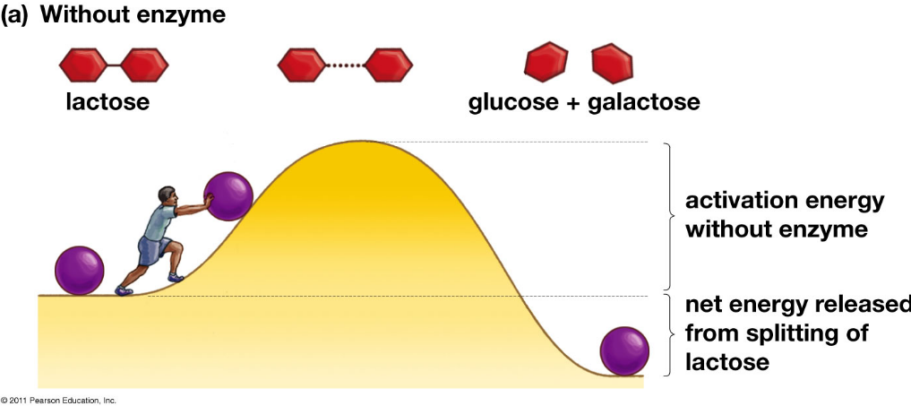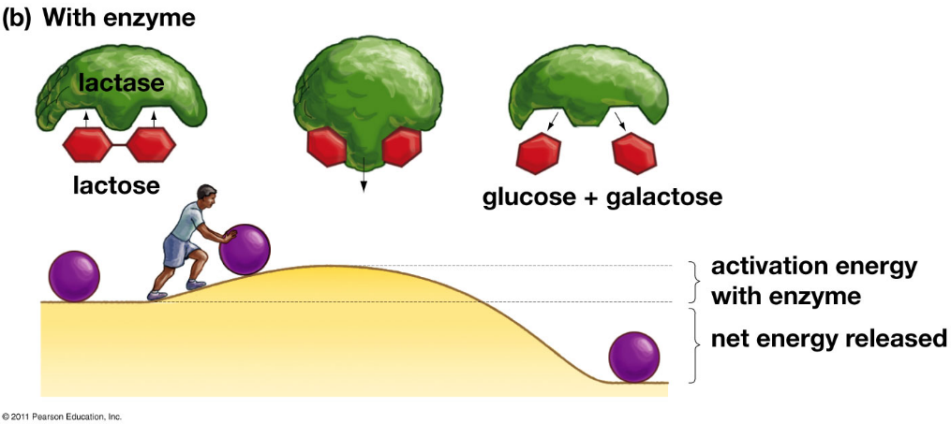
(from Krogh, Biology -- A Guide to the Natural World, Fifth Edition)

To calculate the number of lactose molecules per lactase molecule in question 12, we used the amount of lactose and lactase solutions added to the test tube, the concentrations of lactose and lactase in the solutions, and the molecular weight of lactose (342) and lactase (approximately 150,000-300,000).

If you want to introduce lactose-free milk, you can use the following question after question 12.

13a. A person who has lactose intolerance can drink lactose-free milk without symptoms. This allows them to benefit from the protein, calcium and vitamin D that milk provides. Explain how a manufacturer can use lactase to produce lactose-free milk.

13b. Do you think lactose-free milk contains glucose? yes ___ no ___
If yes, where did the glucose come from?

How Too Little Lactase Can Cause Symptoms When a Person Drinks Milk
To help your students understand the structure and function of the small intestine, you can use the analysis and discussion activity, “Structure and Function of Cells, Organs and Organ Systems” (https://serendipstudio.org/exchange/files/StructFunctCellOrganSHO.pdf).
The liver further processes many of the products of digestion that are absorbed into the blood circulating through the small intestine. For example, after a person drinks milk, galactose is converted to glucose-1-phosphate. Also, if blood glucose levels get too high (e.g., after a meal), much of the glucose is stored in glycogen molecules in the liver. | 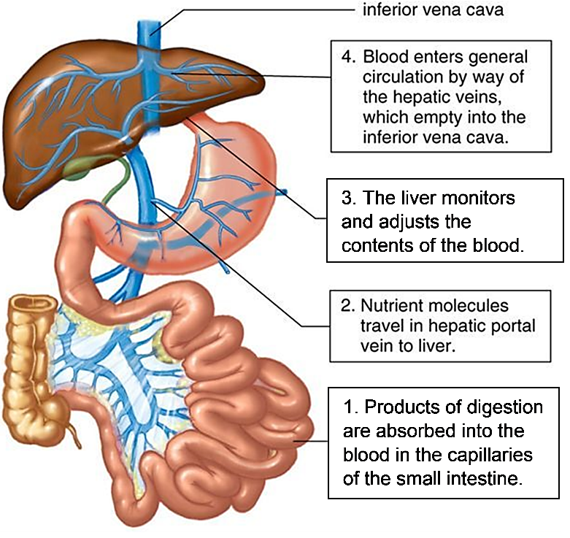  (https://i.pinimg.com/originals/93/58/06/93580666108475bfaf010e1647363822.jpg)

Human babies and the babies of all other mammals depend on milk for their nutrition. Almost all babies produce lactase. In contrast, many adults produce very little lactase. The decrease in production of lactase as a person gets older is called lactase non-persistence.

The alleles of the gene for lactase differ in the nucleotide sequence in their regulatory DNA; this difference influences the rate of transcription of the coding DNA for the protein, lactase, and thus influences the rate of lactase production in cells in the small intestine.
- Lactase persistence alleles result in substantial production of lactase throughout life.
- The lactase non-persistence allele results in substantial production of lactase by infants, but very low production of lactase in adults.
Thus, for virtually all infants and for adults with lactase persistence, the cells of the small intestine produce enough lactase so all or most lactose molecules are broken down to glucose and galactose, which are absorbed from the lumen of the small intestine into the blood.

In lactase non-persistence, lactose that is not digested in the small intestine reaches the colon of the large intestine where lactose can cause symptoms (see graphic and flowchart below). This can result in lactose intolerance as a young child grows toward adulthood. Fewer than 1 in 60,000 newborns have lactose intolerance. However, lactose intolerance is very common among adults, especially in Asia and Africa, where most people are lactose intolerant.

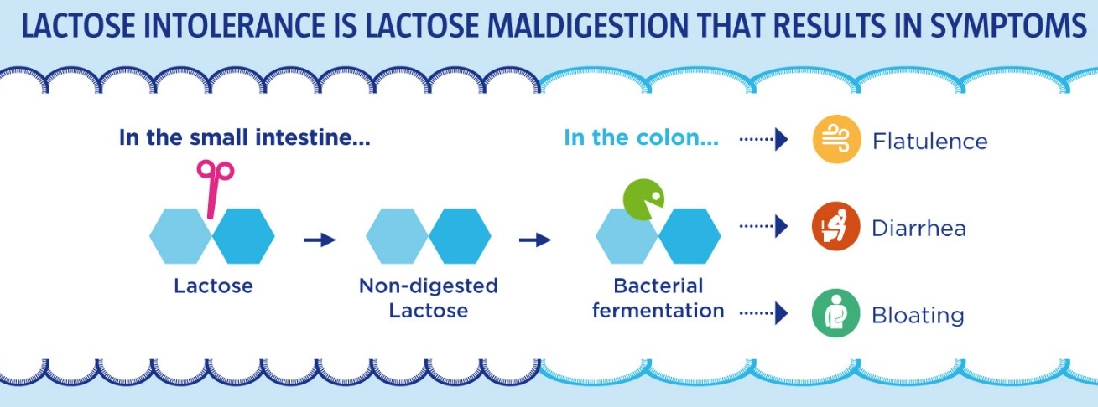
X
(https://www.yogurtinnutrition.com/wp-content/uploads/2017/04/dii002-capsules_infographie_ang-5.jpg)

bacterial
fermentation
lactose in the colon short-chain fatty acids + gases (e.g. CO₂ & H₂)

hypertonic mixture of water, lactose, and short-chain fatty acids
flatulence and
reduced osmotic resorption of water diarrhea discomfort

lactose intolerance

Given this physiology, it is surprising that lactase non-persistence is only loosely correlated with lactose intolerance. Some people who have lactase non-persistence do not have lactose intolerance, e.g., because lactase is produced by bacteria in their small intestines. Some people who think that they have lactose intolerance actually produce normal levels of lactase, so they can digest lactose and their symptoms presumably are due to other causes, such as:
- a chance coincidence between milk consumption and symptoms that gives rise to an inaccurate causal hypothesis
- an allergic reaction to one or more of the proteins in milk.
Lactose intolerance is not life-threatening, but milk allergies can be life-threatening. If a person has symptoms such as hives, wheezing, shortness of breath, or itching, tingling or swelling around the lips after consuming milk, he/she should seek medical advice and probably be tested for milk allergies. (A good summary of milk allergy is available at https://www.mayoclinic.org/diseases-conditions/milk-allergy/symptoms-causes/syc-20375101.)

Dairy products are an important source of calcium, protein and some vitamins. People with lactose intolerance can continue to gain the nutritional benefits of dairy products, but minimize symptoms by:
- using lactase supplements
- consuming dairy products with reduced lactose due to treatment with lactase (e.g. lactose-free milk) or due to fermentation by bacteria (e.g. traditionally made cheese or yogurt)
- consuming small amounts of dairy products at multiple times during the day
- gradually increasing regular consumption of modest amounts of dairy products which can select for lactase-producing bacteria in the small intestine.

Lactase persistence alleles provide an example of natural selection in humans. Lactase non-persistence alleles are nearly universal in mammals and were nearly universal in early humans. When some groups of humans began raising dairy animals, milk became available for consumption by older children, teens and adults. The ability to digest milk without diarrhea appears to have been particularly favored by natural selection during times of famine or prevalent diarrheal diseases. So, lactase persistence alleles were favored by natural selection and became common in many of the groups that raised dairy animals (https://www.nature.com/articles/s41586-022-05010-7). If you want to expand your students’ understanding of natural selection and lactose intolerance, you can show them the video with review questions, “Got Lactase? The Co-Evolution of Genes and Culture” (https://media.hhmi.org/biointeractive/interactivevideo/gotlactasequiz/). Different lactase persistence alleles are observed in European and African herding groups. This illustrates convergent evolution – the independent evolution of similar characteristics in different populations.

For additional information on lactose intolerance, see:
- “Lactose Intolerance” (https://www.niddk.nih.gov/health-information/digestive-diseases/lactose-intolerance)
- “The Science behind Lactose Intolerance” (https://www.carolina.com/teacher-resources/Interactive/the-science-behind-lactose-intolerance/tr38902.tr?s_cid=em_ctgen1_201609)

The analysis of lactose intolerance in this section provides a good opportunity to discuss the Crosscutting Concept: "Cause and effect: Mechanism and Prediction: Cause and effect relationships can be suggested and predicted for complex natural and human designed systems by examining what is known about smaller scale mechanisms within the system."

Jayden’s problem is different from Maria’s problem.
Sucrose is familiar to students as "sugar". Sucrose is found in sugar cane, sugar beets, and fruits. Fruits also contain the monosaccharides, glucose and fructose.

Sucrase deficiency is much rarer than lactase non-persistence (roughly 1 in 2000 people). Mutations that cause sucrase deficiency disrupt the production of sucrase or alter the structure and impair the function of sucrase. When an affected individual eats sucrose, he or she will typically experience abdominal pain, bloating, excess gas production, and diarrhea. Dietary restriction and enzyme replacement are recommended treatments. Sucraid contains an enzyme that digests sucrose; this enzyme is invertase, but in this context it is called sacrosidase, perhaps because it is derived from Baker’s yeast (Saccharomyces cerevisiae). For additional information see https://www.iffgd.org/other-disorders/congenital-sucrase-isomaltase-deficiency-csid.html.

To answer questions 16 and 17, students should apply what they have learned in previous sections.

Astute students will answer question 18a accurately, based on the first paragraph on page 6 of the Student Handout. If other students disagree, you can invite them to try to persuade each other, but we recommend that you leave the predictions uncertain to increase interest in the experiment in this section.

Enzyme specificity can mean that an enzyme only works on one substrate or pair of substrates. However, some enzymes act on a specific type of chemical bond flanked by specific chemical structures. For example, proteins are digested by the enzymes shown in this figure. Amino-peptidase and carboxy-peptidase cleave single amino acids from the ends of a peptide molecule. Each of the other enzymes shown cleave peptide bonds on the carboxyl group side of the amino acids listed on the right (https://basicmedicalkey.com/protein-digestion-and-amino-acid-absorption/). Another example is alpha amylase which can hydrolyze alpha-1-4 glycosidic linkages in starch and glycogen. | 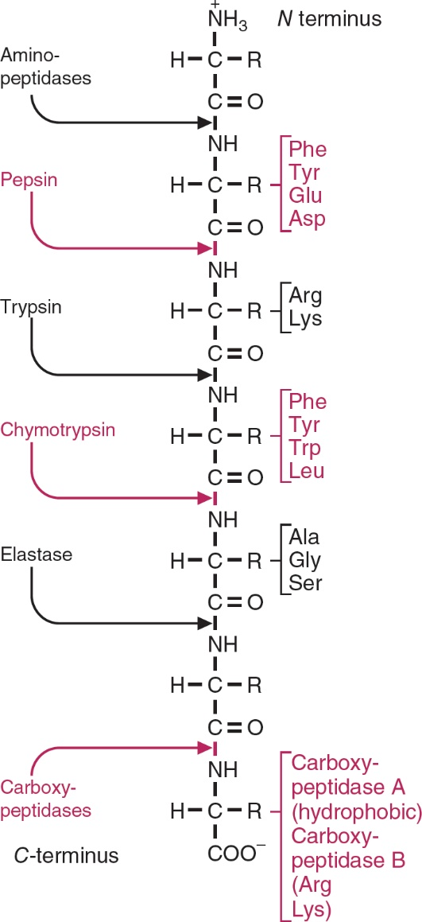

This figure (from question 21a) indicates that sucrose and lactose have very different shapes. The black balls represent carbon atoms; the red balls represent oxygen atoms; and the gray balls represent hydrogen atoms. | 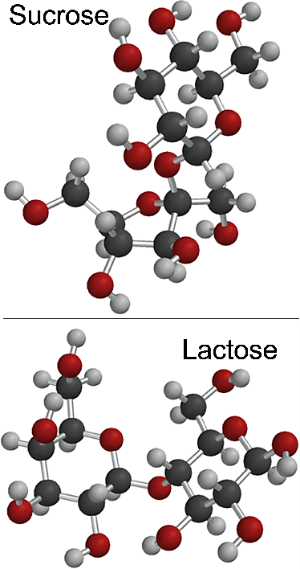

Some textbooks describe a lock and key model of enzyme specificity. However, enzymes are not rigid like a lock in a door. Instead, enzymes are flexible and dynamic. Often, the active site changes shape when the substrate binds to the active site (https://www.ncbi.nlm.nih.gov/pmc/articles/PMC2546551/). This change in shape is called induced fit. Induced fit is illustrated in the recommended 1.8-minute video, “Enzyme Action and the Hydrolysis of Sucrose” (https://www.youtube.com/watch?time_continue=26&v=XAw6DH1SMAc) and in the figure in question 21b. We recommend that you introduce the term “induced fit” (which is not included in the Student Handout) and explain that induced fit is observed in many enzymes.

Interpreting an Experiment with Starch and Saliva
In this section, students use concepts covered in the previous sections to interpret the results of another experiment presented in the video, “Experiment with Salivary Amylase Enzyme”, available at https://www.youtube.com/watch?v=YiW9PcUwL4g.

Alpha amylase is present in saliva and breaks down starch into shorter oligosaccharides. The following table gives the color of iodine reacting with various polysaccharides.

Polysaccharide | Color
Amylose (linear starch molecule; about 30% of starch) | Dark blue
Amylopectin (branched starch molecule; about 70% of starch) | Purple
Oligosaccharides | Violet, pink or no color
(https://www.slideshare.net/namarta28/qualitative-tests-for-carbohydrates-35884145).

Starch digestion begins in the mouth and continues in the small intestine, which has another amylase (secreted by the pancreas), plus two enzymes in small intestine epithelial cells that digest oligosaccharides and the disaccharide maltose to glucose monosaccharides that can be absorbed into the blood. This example illustrates how digestive enzymes are produced by multiple organs in the digestive system, including the salivary glands, stomach, small intestine, and pancreas.

Students should be aware that enzymes are made by cells throughout the body for many different purposes. For example, enzymes synthesize needed molecules by combining two substrate molecules.

Sources for Figures in Student Handout
- Figure of woman with symptoms on page 1 – https://cdn6.littlethings.com/app/uploads/2016/10/embeddedIMG_Symptoms-TreatmentOfLactoseIntolerance_850px_2-600x600.jpg
- Figure showing lactose → galactose + glucose on page 1 – modified from https://haygot.s3.amazonaws.com/questions/1140605_1290313_ans_1334b1ff528540fab481ba95a8c058e2.png
- Enzyme figure on page 4 – modified from https://o.quizlet.com/LCGZXHjfsA0SPoTfvV6Zzw_b.png
- Digestive system figure on page 5 – modified from https://www.niddk.nih.gov/news/media-library/18290
- Figure showing sucrose → glucose + fructose on page 6 – modified from https://en.wikipedia.org/wiki/File:Sucrose_condensation.svg
- Sucrose and lactose figure on page 8 – modified from http://iverson.cm.utexas.edu/courses/310N/MOTD%20Fl05/MOTDsp04/Disaccharides.html
- Sucrase figure on page 8 – modified from https://www.bestdigestiveenzyme.com/sucrase-digestive-enzyme/

Related Activities
To introduce your students to the effects of pH and temperature on enzyme activity, you may want to use the online simulation, “Lactase Enzyme Activity with Data Analysis”
(https://sites.google.com/site/biologydarkow/enzymes/lactase-enzyme-simulation).

Additional activities to help students understand the functions of proteins are presented in "Understanding the Functions of Proteins and DNA" (https://serendipstudio.org/exchange/bioactivities/proteins)
The Teacher Notes present a sequence of activities that will help students understand the basic structure and function of proteins and DNA. To understand how genes influence our characteristics, students learn that different versions of a protein can result in different characteristics, and a gene in the DNA determines which version of a protein is synthesized by a person’s cells. This information is conveyed through a PowerPoint with a sequence of discussion questions and videos and a Student Handout. This sequence can be used in an introductory unit on biological molecules or to introduce a unit on molecular biology. (NGSS)

Students can expand their understanding of enzymes in the bioengineering design challenge included in "Alcoholic Fermentation in Yeast – A Bioengineering Design Challenge", available at https://serendipstudio.org/sci_edu/waldron/#fermentation. This multi-part minds-on, hands-on activity helps students to understand both alcoholic fermentation and the engineering design process. Students use their understanding of enzymes to propose the optimum sucrose concentration and temperature to maximize rapid CO₂ production, and then use the engineering design process to test their proposals. (NGSS)

By Dr. Ingrid Waldron and Lori Spindler, Department of Biology, University of Pennsylvania, © 2024. These Teacher Preparation Notes and the related Student Handout are available at https://serendipstudio.org/sci_edu/waldron/#enzymes.
Quotations are from https://www.nextgenscience.org/ and http://www.nextgenscience.org/sites/default/files/HS%20LS%20topics%20combined%206.13.13.pdf.
A cheaper alternative is to purchase lactase capsules or pills from a web supplier or your pharmacy. One teacher has reported success with Webber Naturals Lactase Enzymes Capsules Extra Strength; dissolve the contents of three lactase capsules in 50 mL of water. Another teacher has reported success with the following procedure for lactase pills. Use a mortar and pestle to crush four tablets. Suspend the crushed tablets in 50 mL of water and keep the mixture/solution on a stir plate during the lab. (You may want to filter the mixture through a coffee filter held in a kitchen sieve or funnel to remove any cellulose.) Have students use 3 mL (instead of 1 mL) of this solution. (12,000-18,000 lactose units is roughly equivalent to 1 g of lactase, but, if you use this approach, the experiment will require more lactase because of the poor solubility of the lactase pills.) If you try either of these approaches, you should pilot test ahead of time, since some capsules or pills result in false positives.
In the Student Handout, we describe this enzyme as sucrase, in accord with many sources that equate sucrase and invertase, since both invertase and sucrase catalyze the breakdown of sucrose to fructose and glucose. However, these enzymes act at slightly different points in the sucrose molecule. Purchased invertase is typically derived from yeast, whereas sucrase is present in the human small intestine.
In order to conserve materials and thus reduce the cost of supplies, you can use smaller test tubes and correspondingly smaller amounts of each solution. If you do this, you will need to modify the instructions in the Student Handout.
Most people with diabetes use a glucometer to test their blood glucose levels (https://www.fda.gov/medical-devices/vitro-diagnostics/blood-glucose-monitoring-devices).
Other conditions may be more common causes of symptoms after eating fruit (https://www.ncbi.nlm.nih.gov/pmc/articles/PMC3934501/). Sucrase also digests maltose and oligosaccharides, so people with sucrase deficiency also experience symptoms after eating grains and other foods that contain starch.
You may want to show your students the 5.5-minute video, "Enzymes" (https://www.youtube.com/watch?v=qgVFkRn8f10&t=193s) which reviews many of the concepts introduced in this activity. However, you will want to point out that at about 2.5 minutes the explanation of the function of lactase is not accurate since it says that lactase splits the disaccharide lactose into monosaccharides which can be "digested", when it should say the monosaccharides can be "absorbed into the blood".
NGSS indicates that this activity is aligned with the Next Generation Science Standards (https://www.nextgenscience.org/).

